Make Up Lesson Policy
Makeup lessons can be booked in at the pro shop by phone or in person. Please note the provisions below.

Provisions for Makeup lessons when Student Sick or Away
- Maximum of 2 makeup lessons per term, per child
- Students Lesson fees must be up to date to book in makeup lesson.
- Have notified Nepean Tennis 1 hour prior to their lesson commencement.
- If there is a class available for the level of the child
- Makeup lessons to be taken within the current term.
- Makeup lessons will not rollover to the next term.
- Make up lessons are non-refundable.
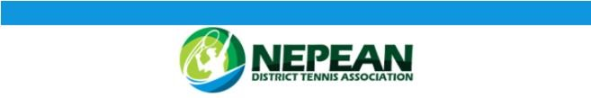
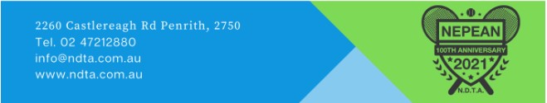
- It is the responsibility of the parent/guardian to booked make up lessons due to absence or illness. It is in your child’s best interest that absences are restricted to genuine illness’s/ medical conditions. Consistency is the key to your child’s progression.

Wet Weather & Extreme Heat Cancellations
Lessons cancelled due to wet weather/Extreme Heat, need to be rescheduled before the end of term.

If you are unable to reschedule in any other class of the same level offered by Nepean Tennis, please email info@ndta.com.au

*Lesson credits are not redeemable for CASH

